**Module Title**

**Internet Technologies**

**Assessment Type**

**Portfolio Coursework**

**Year**

**2024-25**

CS & DF- L3_sem-2

**Student Name: Osama Jat**

**UWE ID: 24030174**

**Assignment Submission Date: 26-6-2024**

**Week: 4**

Task 1 - Getting started with moqups.com account setup and tools

Overview

1. Created a free account in moqups.com. Follow with the click on the a Create a Free Account. I can get. this screen. Let’s go with Sign up with Google.

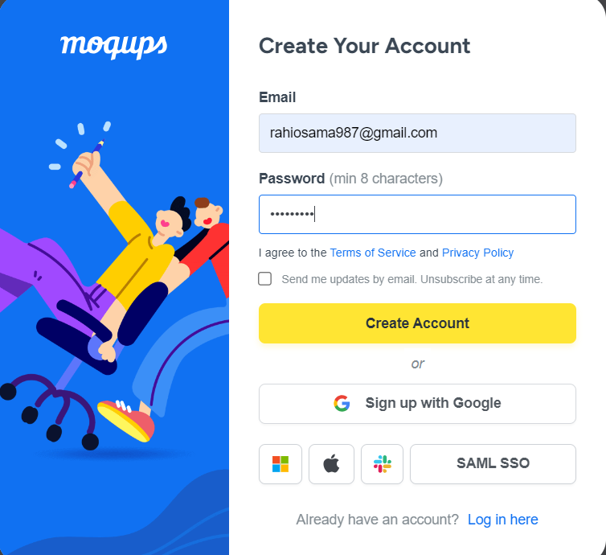  
  
  
  
  
  
 2.You will see this screen. Select Blank Project & Rename as “Wireframe & Mockup

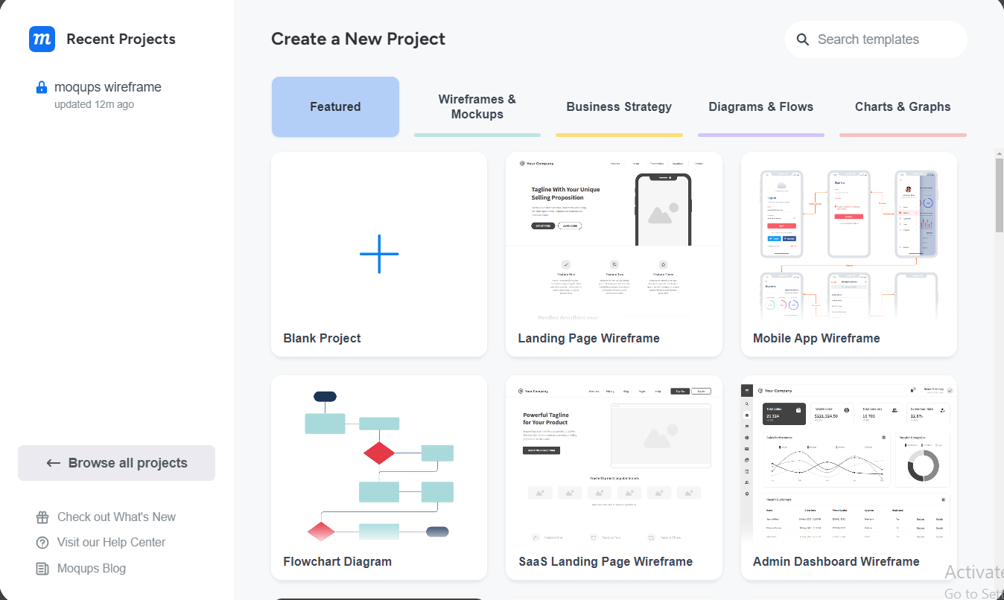

1. I have saw this screen

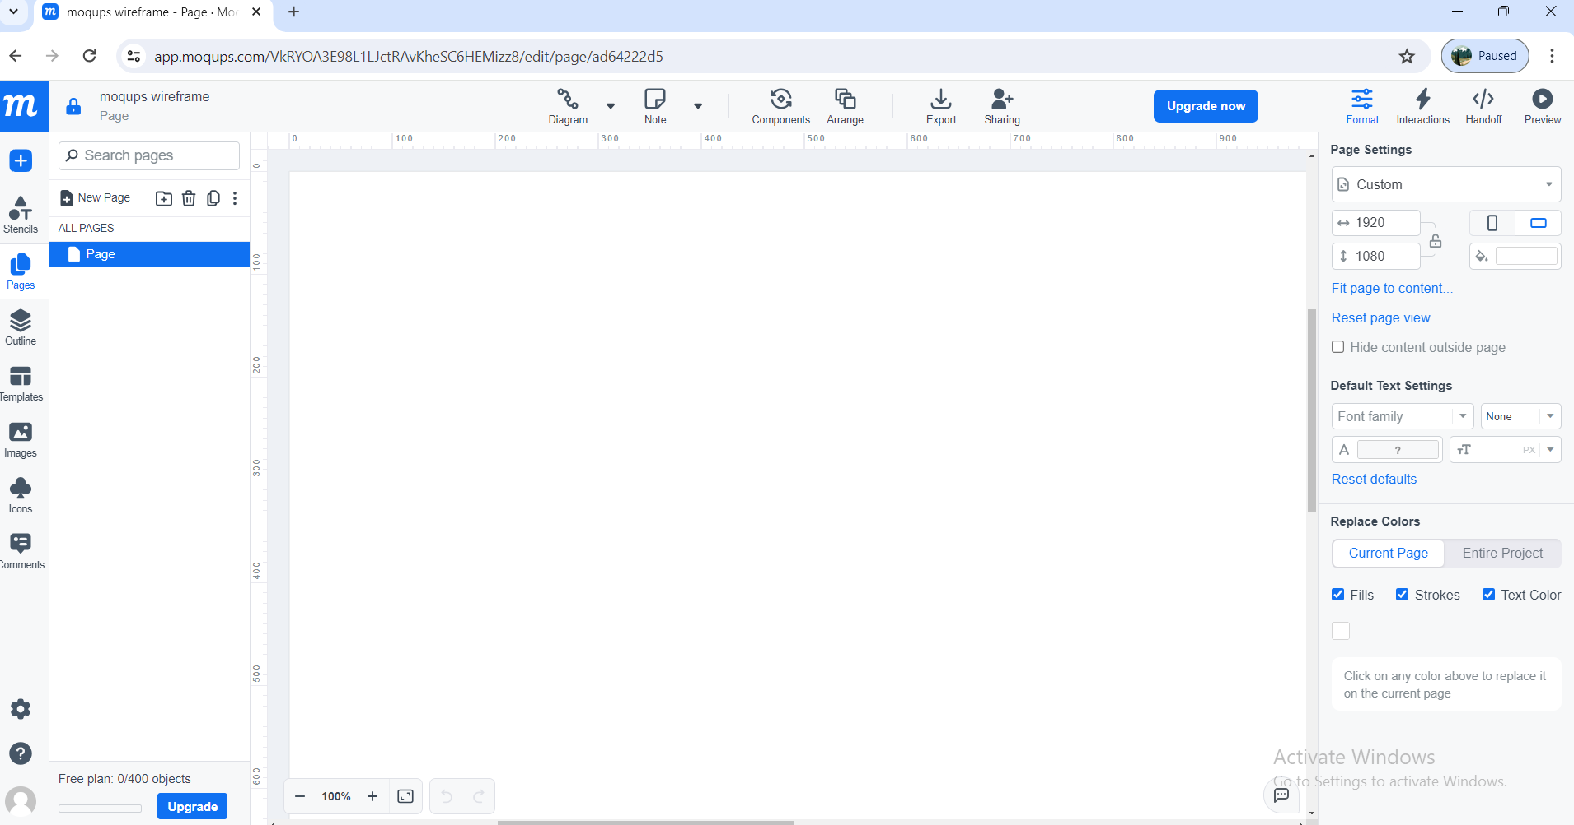  
  
  
  
  
  
  
  
  
  
  
  
  
  
  
  
  
  
  
  
  
  
  
4. Checked for components/icons at left side:

1. Stencils  
   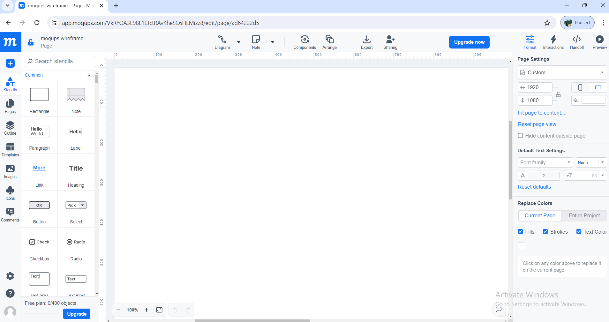  
   b. Pages

  
  
  
c.Images

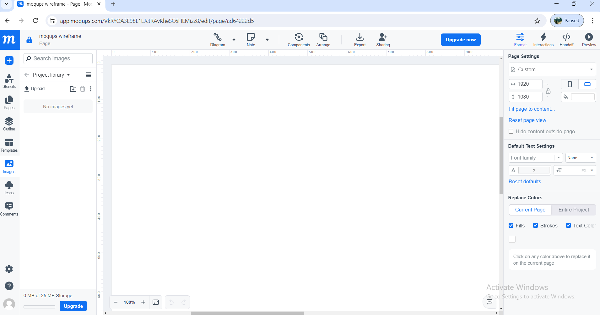  
  
5. **Pages Icon:**  
  
b. Select Page  
  
  
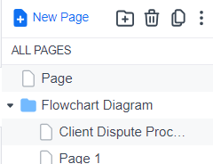  
  
  
  
  
  
  
  
  
c. Right Click on Page > Rename. Now let’s Rename as “Wireframe1”  
  
  
  
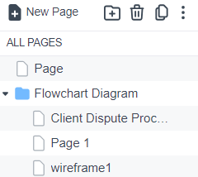  
  
  
  
  
  
d. Right Click > Page Settings. Set Width of 800 and Height of 700  
  
  
  
  
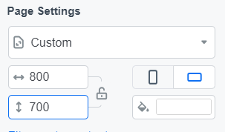  
  
  
  
  
6. Checked in **Stencils Icon**  
  
  
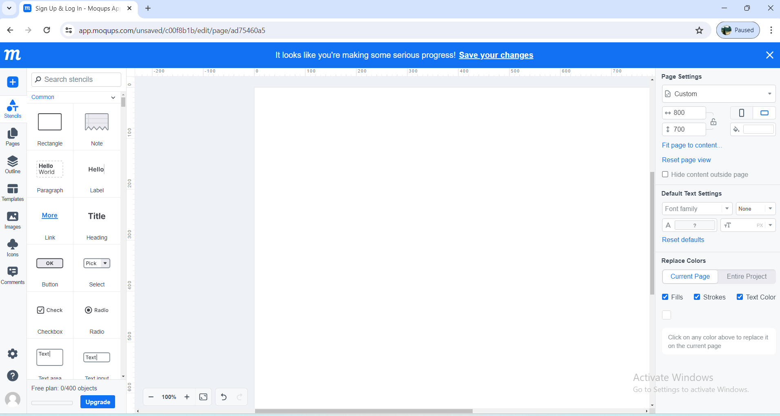

7. Drag and drop some of the objects in Stencils that you can use to create wireframe. Do not limit with

what is just mentioned below.

a. Rectangle

b. Link

c. Heading

d. Paragraph

e. Image Placeholder

f. Banner

g. Search

h. Menus & Navigation

i. Form Controls

j. Table

k. Calendar

l. Map and

m. Others you can use  
  
  
